**\. ONLINE VOTING SYSTEM UML DIAGRAMS**

**S . JAHNAVI**

**(192011242)**

**1.USE CASE DIAGRAM**

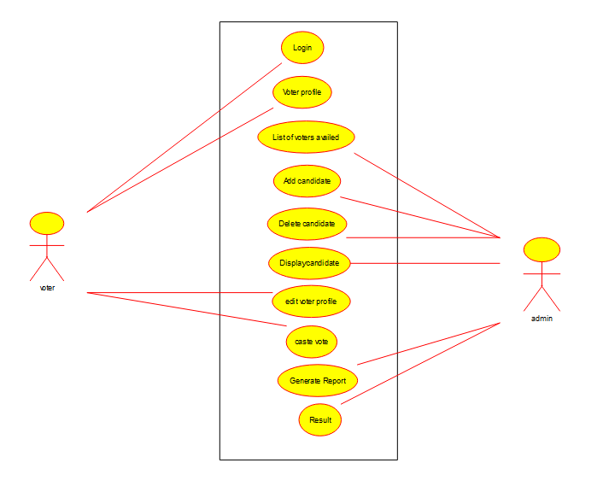

**2.SEQUENCE DIAGRAM**

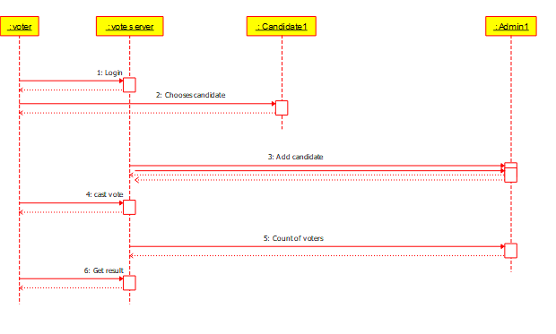

**3.CLASS DIAGRAM**

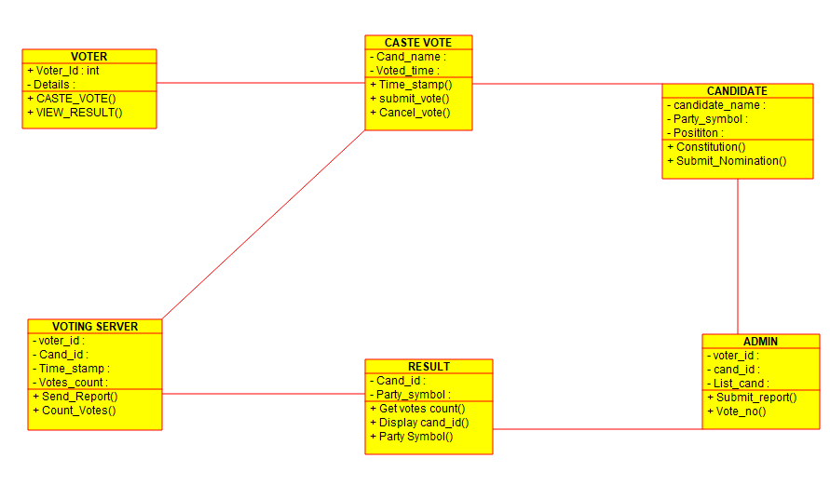

**4.ACTIVITY DIAGRAM**

